|  |
| --- |
| 1.  Write a program that create Series from ndArray. Print all values in the Series using loop and also print the sliced values from the Series. |

Python Code:

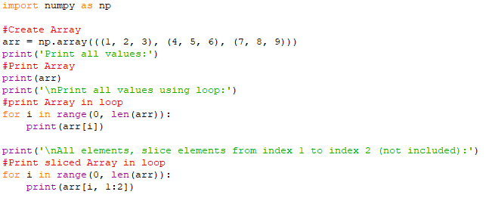

Output:

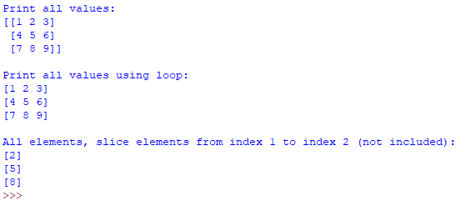

|  |
| --- |
| 2.  Write a program that create reads marks in Series and prints the finds average of marks. |

Python Code:

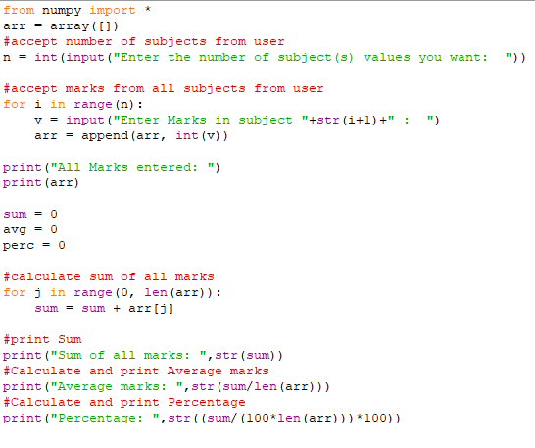

Output:

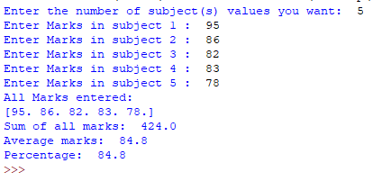

|  |
| --- |
| 3.  Create a Data Frame quarterly sales where each row contains the item category, item name, and expenditure. Group the rows by the category and print the total expenditure per category. (Read 3 values for each category. Total category should be 4). |

Python Code:

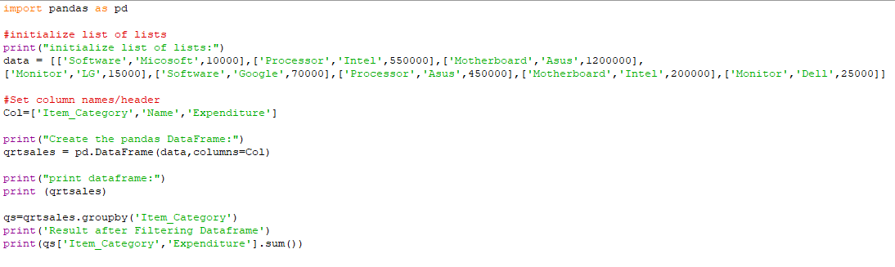

Output:

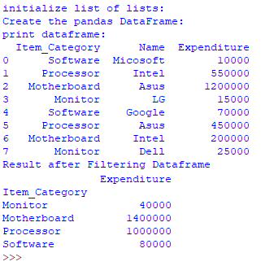

|  |
| --- |
| 4.  Create a data frame for examination result and display row labels, column labels data types of each column and the dimensions. |

Python Code:

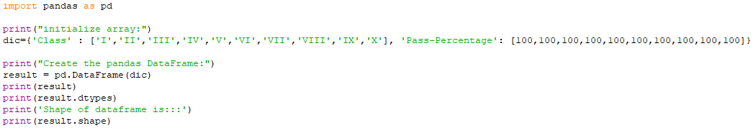

Output:

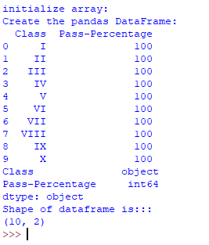

|  |  |  |  |  |  |  |  |  |  |  |  |  |  |  |  |  |  |  |  |  |  |  |  |  |  |  |  |  |
| --- | --- | --- | --- | --- | --- | --- | --- | --- | --- | --- | --- | --- | --- | --- | --- | --- | --- | --- | --- | --- | --- | --- | --- | --- | --- | --- | --- | --- |
| 5.  Create a DataFrame as shown below and perform following operations on it.   |  |  |  |  | | --- | --- | --- | --- | | Product | Company | Quantity | Price | | CPU | Compaq | 40 | 9000 | | Mouse | Dell | 20 | 500 | | Keyboard | HP | 15 | 500 | | Printer | Epson | 5 | 5700 | | Hard Disk | Toshiba | 10 | 2000 | | Plotter | Sony | 5 | 8000 |   a) Add a new column Total Price that contains Total Price of Product (Total Price  = Quantity * Price)  b) Add a new row to the DataFrame with Data – (Scanner, HP, 2, 9500)  c) Display the Product and Total Price of the DataFrame. |

Python Code:

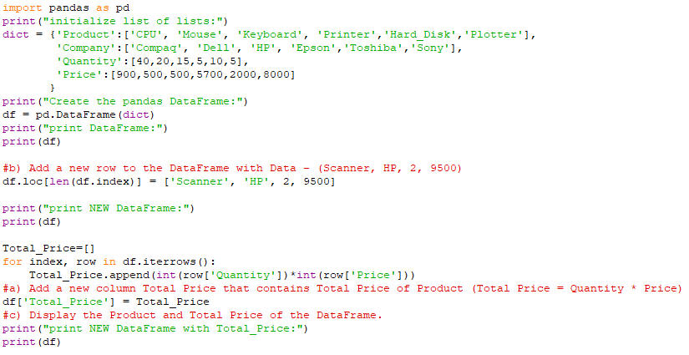

Output:

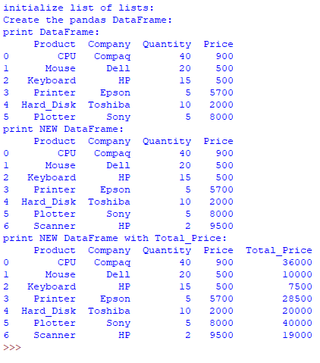

|  |
| --- |
| 6.  Create a DataFrame that reads Employee Data (Employee No, Name, Address, Date of Joining, Salary) from CSV File and displays the details. |

Python Code:

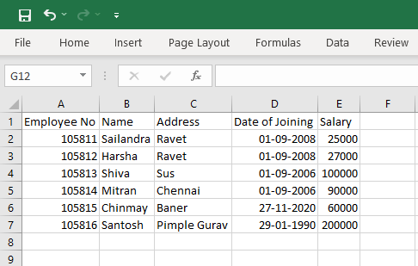

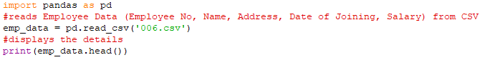

Output:

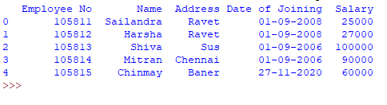

|  |
| --- |
| 7.  Create a DataFrame with details BookID, Book Description, Author, Publisher,Quantity and Price. Store the data into a CSV File with name “Employee_Data”. |

Python Code:

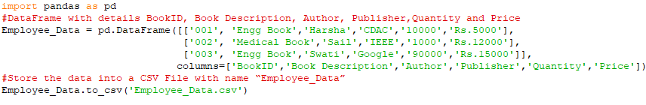

Output:



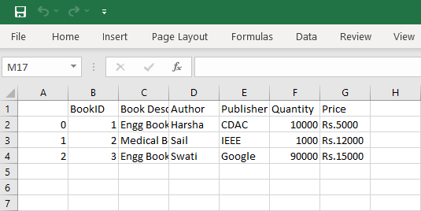

|  |  |  |  |  |  |  |  |  |  |  |  |  |  |  |  |  |  |  |  |  |  |  |  |  |  |  |  |  |  |  |  |  |  |  |  |  |  |  |  |  |  |  |
| --- | --- | --- | --- | --- | --- | --- | --- | --- | --- | --- | --- | --- | --- | --- | --- | --- | --- | --- | --- | --- | --- | --- | --- | --- | --- | --- | --- | --- | --- | --- | --- | --- | --- | --- | --- | --- | --- | --- | --- | --- | --- | --- |
| 8.  Consider DataFrame df as shown below :   |  |  |  |  |  |  | | --- | --- | --- | --- | --- | --- | |  | **name** | **Age** | **weight** | **height** | **runsscored** | | 0 | mayur | 15 | 51 | 5.1 | 55 | | 1 | anil | 16 | 48 | 5.2 | 25 | | 2 | viraj | 17 | 49 | 5.1 | 71 | | 3 | viraj | 17 | 51 | 5.3 | 53 | | 4 | mahesh | 16 | 48 | 5.1 | 51 | | 5 | viraj | 17 | 59 | 5.3 | 50 |   Write commands to :  a) Write command to calculate minimum value for each of the row from subset of dataframe that contains age, weight, height, runsscored  b) Write command to calculate mean for last 3 rows. |

Python Code:

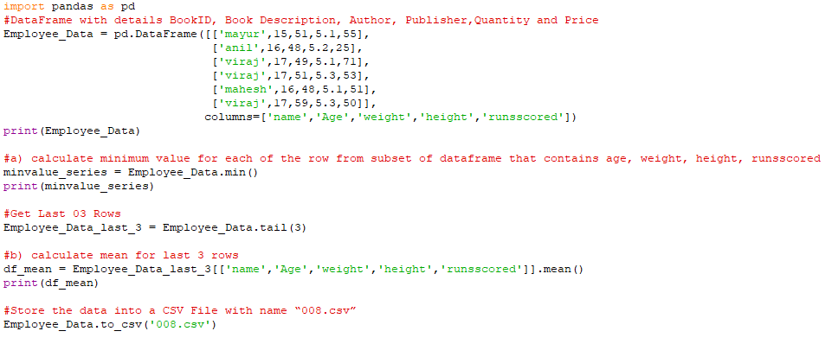

Output:

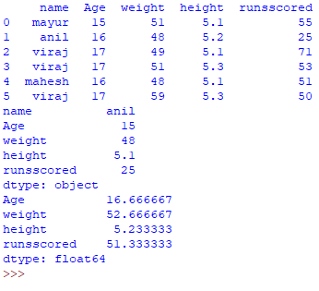

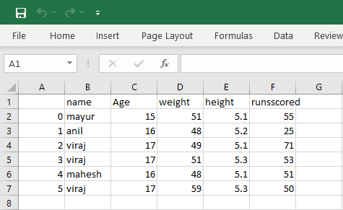

|  |  |  |  |  |  |  |  |  |  |  |  |  |  |  |  |  |  |  |  |  |  |  |  |  |  |  |  |  |  |  |
| --- | --- | --- | --- | --- | --- | --- | --- | --- | --- | --- | --- | --- | --- | --- | --- | --- | --- | --- | --- | --- | --- | --- | --- | --- | --- | --- | --- | --- | --- | --- |
| 9.  Write a code to create following dataframe.   |  |  |  |  |  | | --- | --- | --- | --- | --- | | Booking Code | Customer Name | No of Ticket | Ticket Rate | Booking Clerk | | B001 | Veer | 4 | 100 | Manish | | B002 | Umesh | 2 | 200 | Kishor | | B003 | Lavanya | 6 | 150 | Manish | | B004 | Shobhana | 5 | 250 | John | | B005 | Piyush | 3 | 100 | Kishor |   Do the following:  a) Add column "Total Amount" that calculates total amount of tickets and assign that to new column.  b) Add a new row with values ( B006 , Vijay, 7, 150, John). Calculate the total amount of tickets and assign it to Total Amount column. |

Python Code:

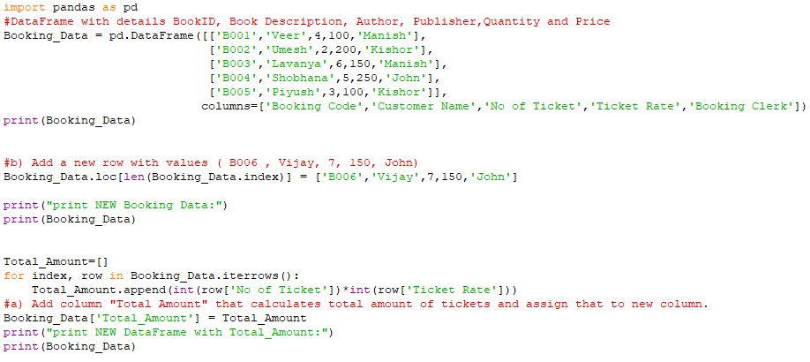

Output:

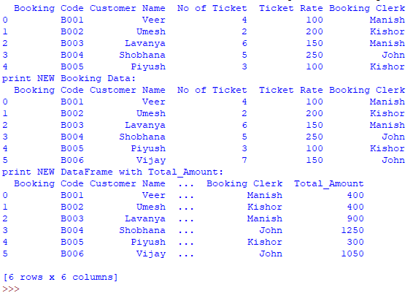

|  |
| --- |
| 10.  Read the subjects and marks/grades for different subject of Class 12 and plot column chart on that. Also display title, x-axis and y-axis labels. |

Python Code:

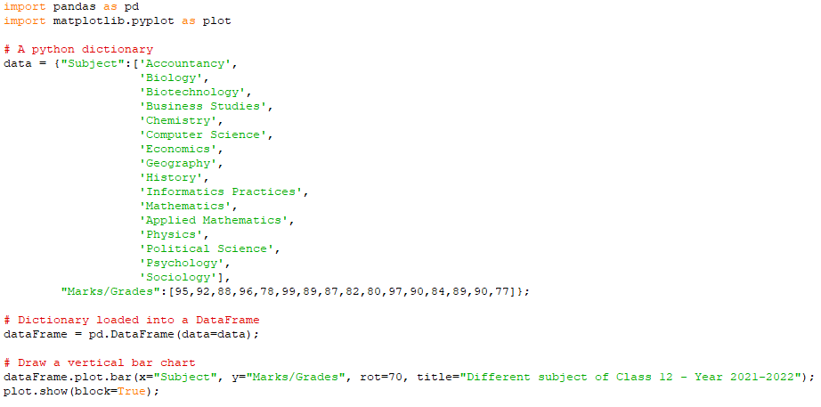

Output:

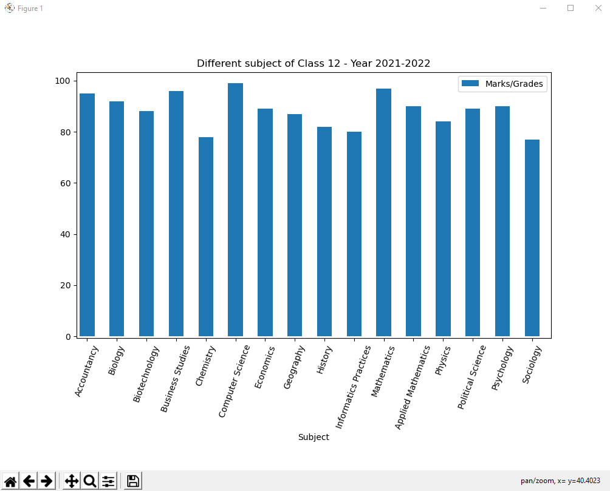

|  |
| --- |
| 11.  Read data from open source (e.g. data.gov.in), aggregate and summarize it. Then plot it using different plotting functions of the Matplotlib library. |

Python Code:

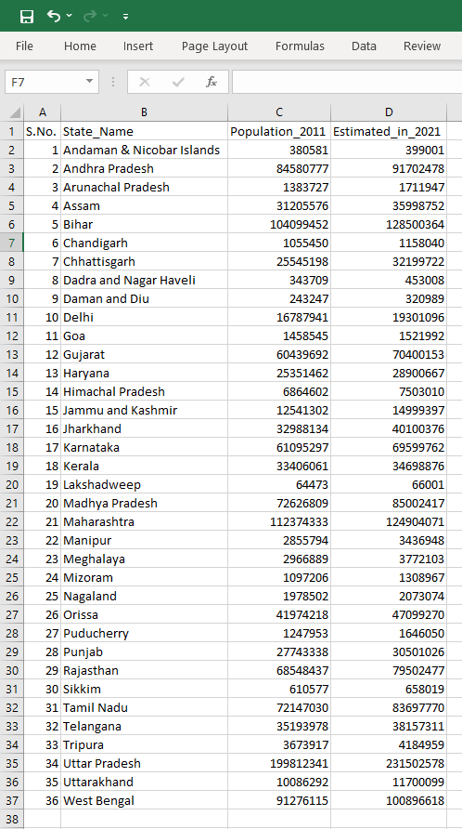

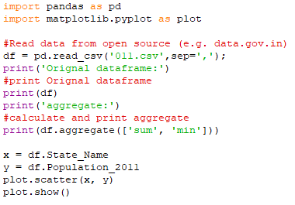

Output:

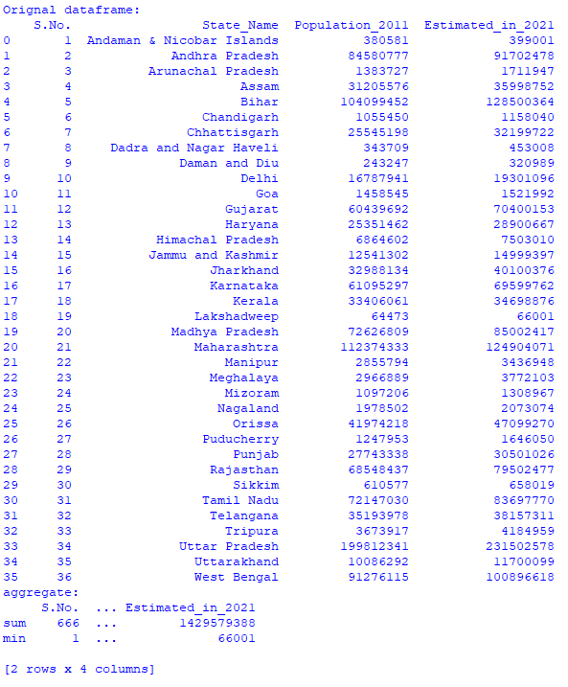

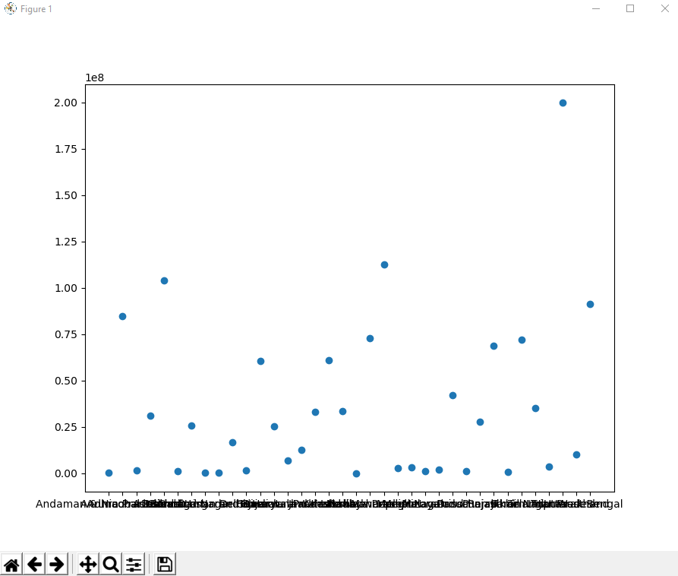

|  |
| --- |
| 12.  Draw the histogram based on the Production of Corn in different Years  'Year':2003,2005,2007,2009,2011,2013,2015,2017,2019,2021  'Production': 7,4,9,19,23,4,16,8,6,25 |

Python Code:

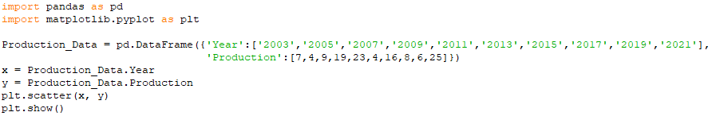

Output:

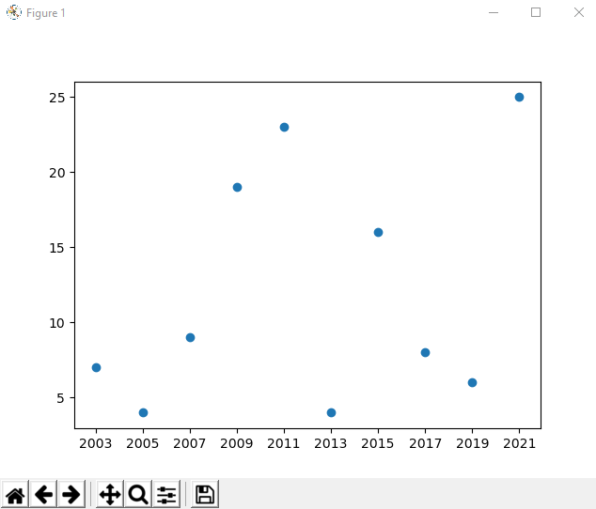

|  |  |  |  |  |  |  |  |  |  |  |  |  |  |  |  |  |  |  |  |  |  |  |  |  |  |  |  |  |  |  |  |  |  |  |  |  |  |  |  |  |  |  |  |  |  |  |  |  |  |  |  |  |  |  |
| --- | --- | --- | --- | --- | --- | --- | --- | --- | --- | --- | --- | --- | --- | --- | --- | --- | --- | --- | --- | --- | --- | --- | --- | --- | --- | --- | --- | --- | --- | --- | --- | --- | --- | --- | --- | --- | --- | --- | --- | --- | --- | --- | --- | --- | --- | --- | --- | --- | --- | --- | --- | --- | --- | --- |
| 13.  Observe the given data for Football Players and their goals scored in the matches. Plot them on the bar chart.   |  |  |  |  |  |  |  |  |  |  |  |  |  |  |  |  |  |  | | --- | --- | --- | --- | --- | --- | --- | --- | --- | --- | --- | --- | --- | --- | --- | --- | --- | --- | |  | | | | | | | | | | | | | | | | | | |  | Ronaldo |  |  | Pele |  |  | Messi |  |  | Gerd Muller |  |  | Eusebio |  |  | Maravilla |  | |  | 783 |  |  | 767 |  |  | 755 |  |  | 735 |  |  | 623 |  |  | 575 |  | |

Python Code:

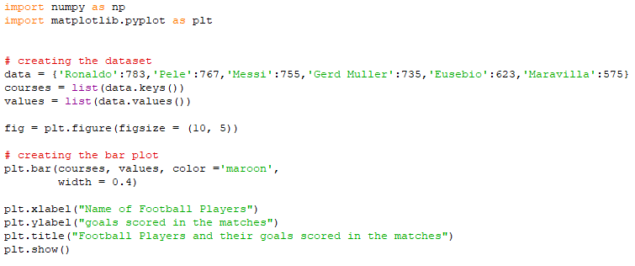

Output:

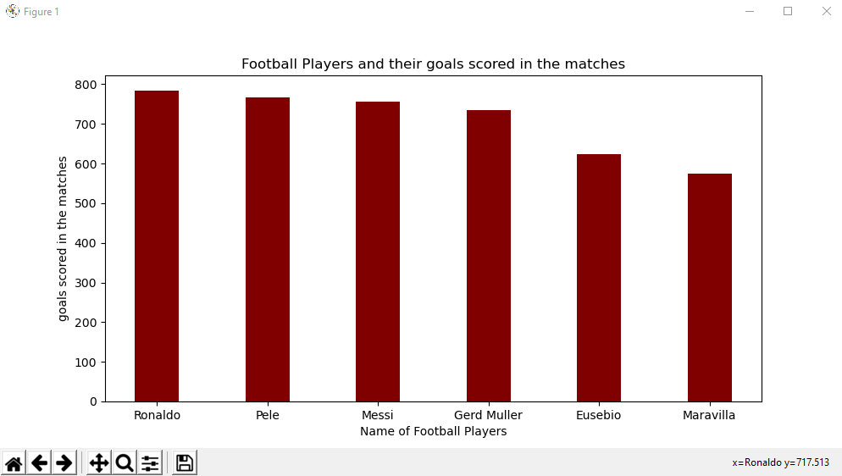

|  |  |  |  |  |  |  |  |  |  |  |  |  |  |  |  |  |  |  |  |  |  |  |  |  |  |  |  |  |  |  |  |  |  |  |  |  |  |  |  |  |  |  |
| --- | --- | --- | --- | --- | --- | --- | --- | --- | --- | --- | --- | --- | --- | --- | --- | --- | --- | --- | --- | --- | --- | --- | --- | --- | --- | --- | --- | --- | --- | --- | --- | --- | --- | --- | --- | --- | --- | --- | --- | --- | --- | --- |
| 14.  Consider the data given below for creating bar and line chart   |  |  |  |  |  |  |  | | --- | --- | --- | --- | --- | --- | --- | | Zones | June | July | Aug | Sept | Oct | Nov | | North | 140 | 130 | 130 | 190 | 160 | 200 | | South | 160 | 200 | 130 | 200 | 170 | 190 | | East | 140 | 180 | 130 | 170 | 190 | 180 | | West | 180 | 190 | 200 | 120 | 180 | 190 | | Central | 110 | 160 | 130 | 110 | 170 | 130 |   a) Create a bar chart to distribution of rainfall from June to Nov for all zones. b) Create line chart to observe any trends from June to Nov. |

Python Code:

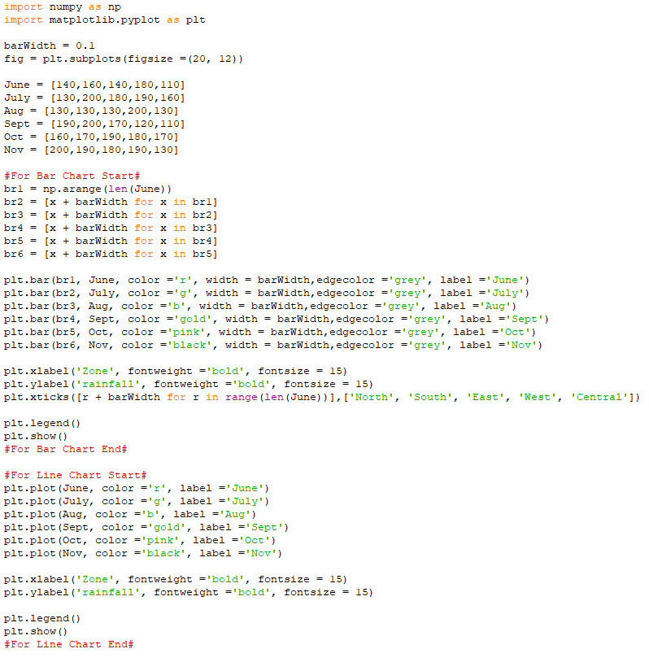

Output:

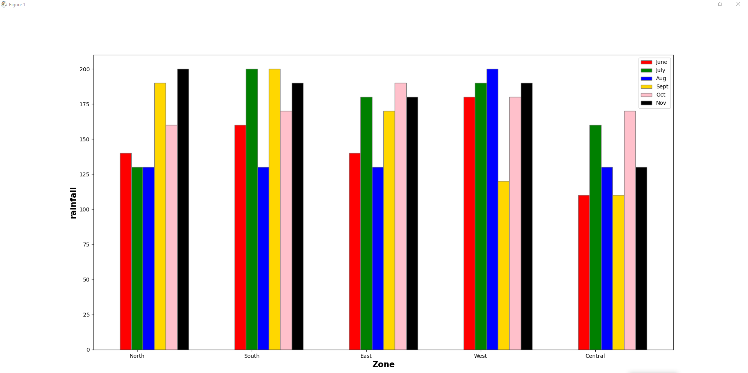

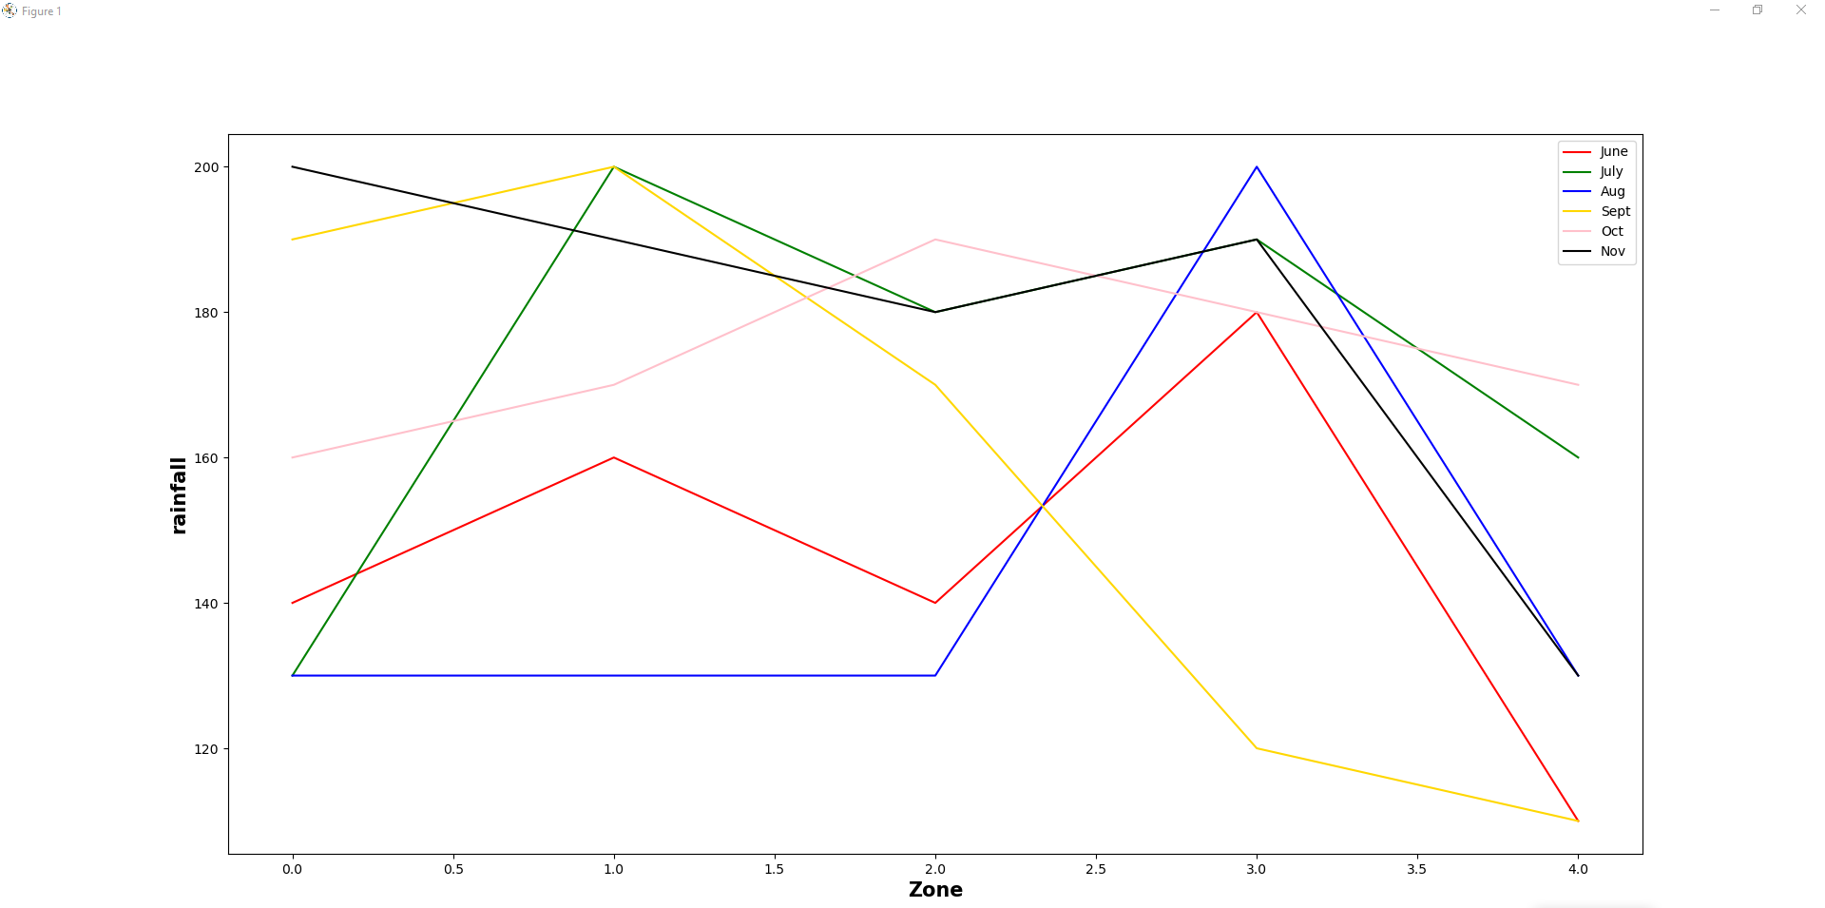

|  |  |  |  |  |  |  |  |  |  |  |  |  |  |  |  |  |  |  |  |  |  |  |  |  |  |  |  |  |  |  |  |  |  |  |  |  |  |  |  |  |  |  |  |  |  |  |  |  |  |  |  |  |  |  |  |  |  |  |  |  |  |
| --- | --- | --- | --- | --- | --- | --- | --- | --- | --- | --- | --- | --- | --- | --- | --- | --- | --- | --- | --- | --- | --- | --- | --- | --- | --- | --- | --- | --- | --- | --- | --- | --- | --- | --- | --- | --- | --- | --- | --- | --- | --- | --- | --- | --- | --- | --- | --- | --- | --- | --- | --- | --- | --- | --- | --- | --- | --- | --- | --- | --- | --- |
| 15.  Write a program in Python Pandas to create the following DataFrame ‘Library’.   |  |  |  |  |  |  |  | | --- | --- | --- | --- | --- | --- | --- | | Bid | Name | Author | Price | Mem_Name | Issue_Date | Status | | B01 | Wings of | A.P.J Abdul | 450 | Pranjal | 2021-04-11 | Not | | Fire | Kalam | Returned | | B02 | The Monk | Robin | 370 | Kunal | 2021-03-15 | Returned | | who sold | Sharma | | his Ferrari |  | | B03 | You Can | Shiv Khera | 350 | Rajat | 2021-04-18 | Not | | Win | Returned | | B05 | Who | Spenser | 450 | Roma | 2021-02-27 | Returned | | moved my | Jhonson | | cheese |  | | B06 | Real | Pattrick | 250 | Sia | 2021-04-23 | Not | | Success | Mather | Returned | |  | Pike |  |   a) Display DataFrame ‘Library’.  b) Display the Book names having price above 350. |

Python Code:

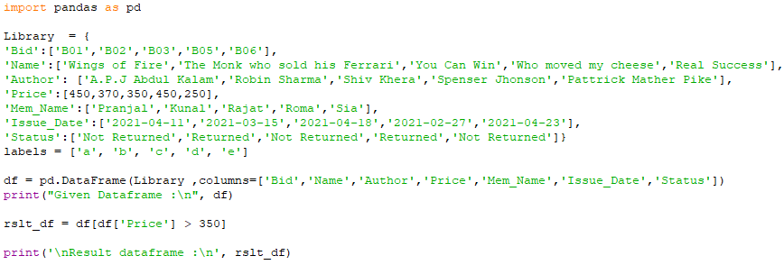

Output:

